ProModel License Manager

This document explains the features and environment included in the ProModel Corporation License Manager dialog. The License Manager functions as a container for licensing key information for any ProModel product operating on your system.

The dialog features:

* ProModel Keys list
* Help
* Refresh
* Close

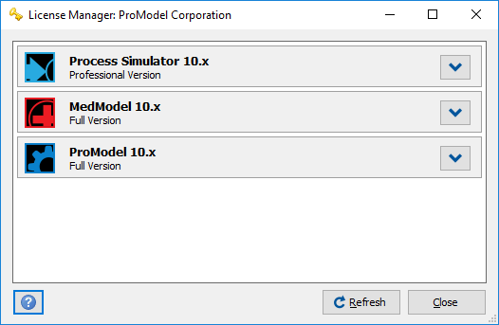

# ProModel Keys list

The primary function of the License Manager is to list all the ProModel products with licensing keys operating on your machine and provide you with any licensing and version information about that product. To view this information, click on the **Expand** button to the right of the product’s name.

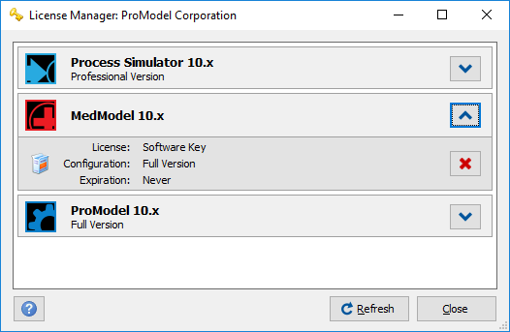

Expanding the list will display License, Configuration, Expiration and Termination information about your product.

## License

The License line will display what type of license key is operating for the selected product. Licensing key options are Software Key, Network Key, USB Key, or Unknown.

## Configuration

The Configuration line provides information about version status the product is currently operating on your machine. Versions include, Full Version, Trial, and Unknown.

## Expiration

The Expiration line provides the date of expiration for your license key, if your license key is expired, expiration grace period or how many days until your license key will expire.

## Terminate Button



To the far right of the licensing information is the Terminate Software Key button. To remove your software key for a ProModel product, select this button. When the Terminate Software Key button is selected, the following warning dialog will appear:

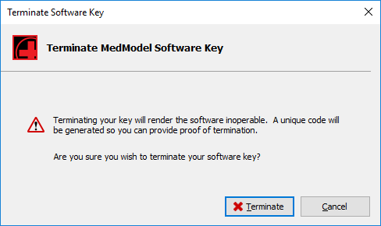

Terminating your software key will render the application inoperable. To continue and verify the termination of your software key, click on the Terminate button. The following termination verification dialog will appear.

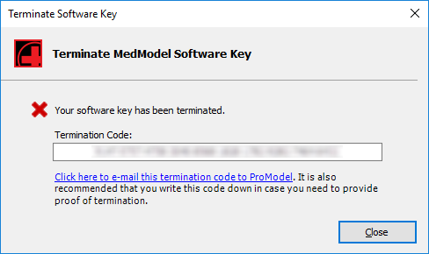

Write down the termination code provided and then click on the link, “Click here to e-mail this termination code to ProModel.” After selecting this link, your default email server will launch a termination form in a new email for you to completely fill out and send to ProModel.

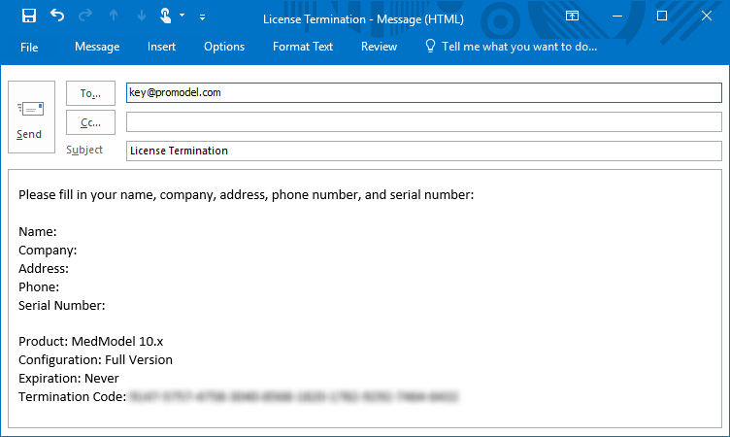

When your computer no longer has license keys for ProModel software, License Manager will appear as below:

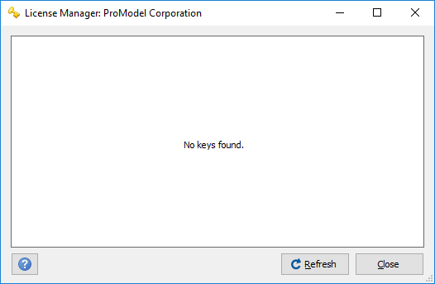

# Refresh

By selecting Refresh, the License Manager will refresh, check for any keys, and display the latest ProModel license information.

